How to do Study Plan questions you’ve already “mastered”.

Say you want to work a couple questions before the exam:

Go to study plan on the left hand menu:

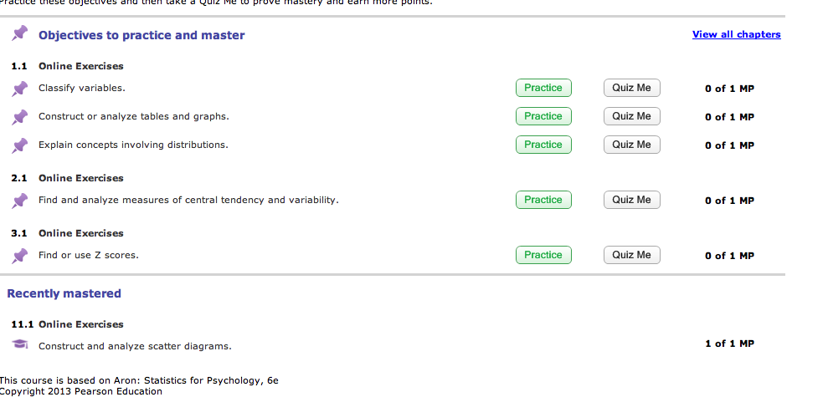

I’ve already mastered the first item, so it looks like I can’t redo those questions.

Hit view all chapters (right corner).

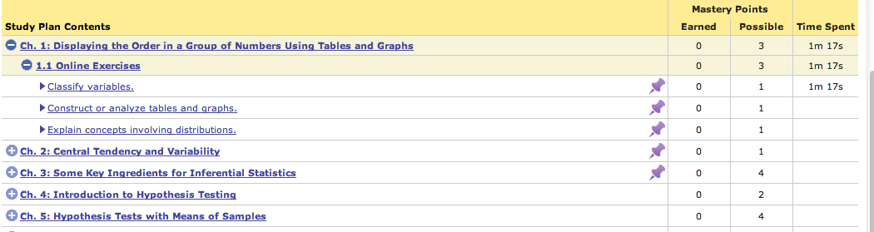

Click on the plus and minus to expand and close.

You can click on 1.1 or 2.1, etc. to get to the original questions.

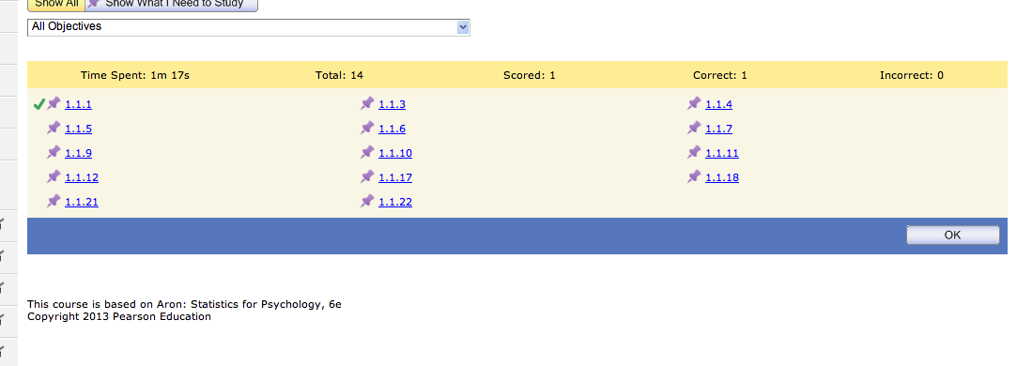

Now you can pick specific questions to work (or you can pick specific objectives like “classify variables” to pick only particular parts of the chapter).

Or you can rework homework/post-tests to practice.